Supplementary Materials
Metabolic profiling of liver in C57BL/6 mice with DSS-induced inﬂammatory bowel disease by untargeted metabolomics analysis
Zhongquan Xin¹, Zhenya Zhai², Hongrong Long¹, Fan Zhang¹, Xiaojun Ni¹, Jinping Deng¹, Lunzhao Yi³*, Baichuan Deng^{1,4}*
¹Guangdong Provincial Key Laboratory of Animal Nutrition Control, National Engineering Research Center for Breeding Swine Industry, College of Animal Science, Subtropical Institute of Animal Nutrition and Feed, South China Agricultural University, Guangzhou, China
²Newhope Liuhe co. Ltd, Chengdu, China
³Yunnan Food Safety Research Institute, Kunming University of Science and Technology, Kunming, 650500, China
⁴ National Engineering Laboratory for Pollution Control and Waste Utilization in Livestock and Poultry Production, Key Laboratory of Agro-ecological Processes in Subtropical Region, Institute of Subtropical Agriculture, Chinese Academy of Sciences, Changsha, China
∗Corresponding authors: Lunzhao Yi & Baichuan Deng
Address for correspondence:
Lunzhao Yi, Yunnan Food Safety Research Institute, Kunming University of Science and Technology, Kunming, 650500, China. Tel.: +86 871 65920302. E-mail address: yilunzhao@kmust.edu.cn
Baichuan Deng, Guangdong Provincial Key Laboratory of Animal Nutrition Control, Subtropical Institute of Animal Nutrition and Feed, College of Animal Science, South China Agricultural University, Guangzhou 510642, Guangdong, China. Tel.: +86 15920905773. E-mail: dengbaichuan@scau.edu.cn

Figure legend
Figure S1
The study process diagram includes sample pre-processing, instrumental analysis, data preprocessing and qualitative analysis, multivariate screening and differential metabolite screening
Figure S2
The total ion chromatograms (TICs) of control group, DSS group, CA group and GA group
Figure S3
Two steps used for metabolites identification, (a) isotope pattern matching and (b) MS/MS spectral library matching
Figure S4
Box-plot of potential metabolites in the four groups: control, DSS, CA and GA group (*p<0.05, **p<0.01, ***p<0.001, ns means no significantly)

Table legend
Table S1
Lists of metabolites identified in liver
Table S2
List of the 52 metabolites which were screened by one-way analysis of variance of metabolites in control group, DSS group, CA group and GA group

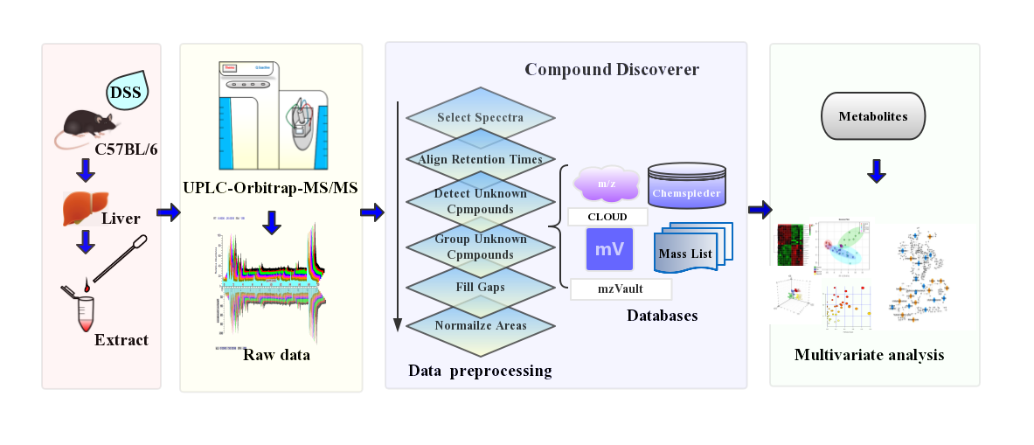
Figure S1

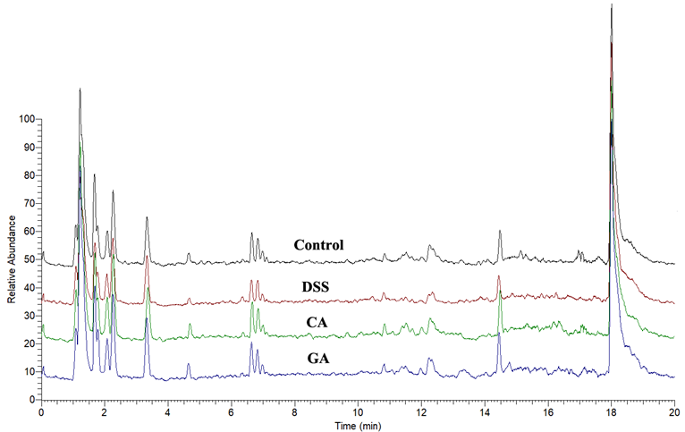
Figure S2

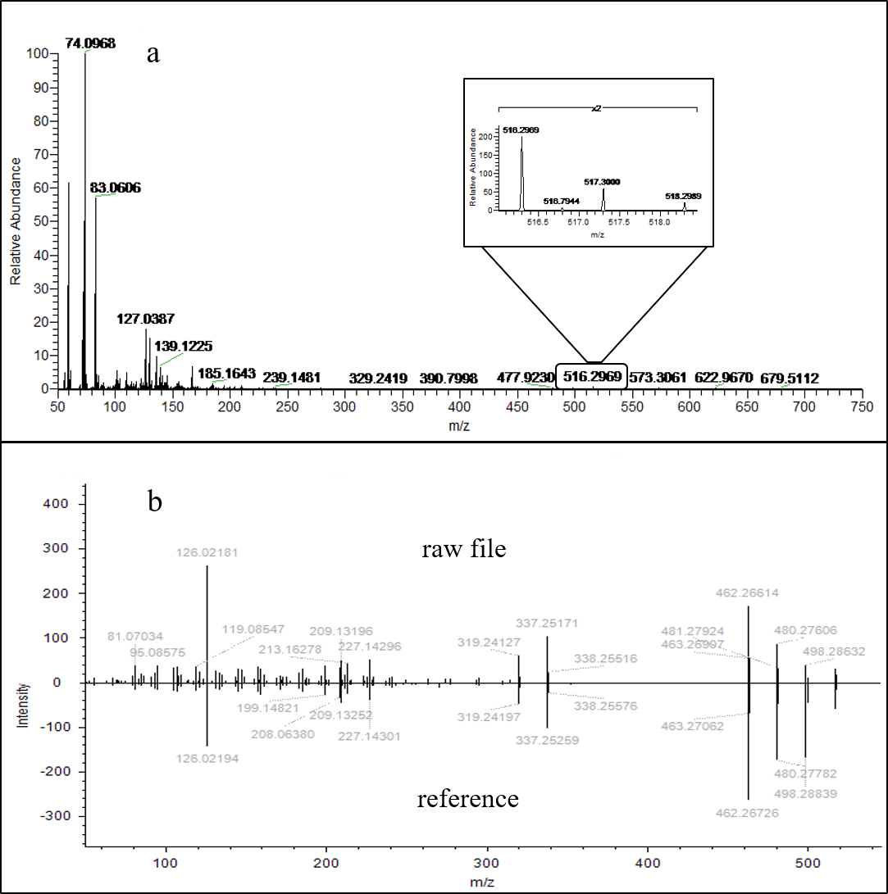
Figure S3
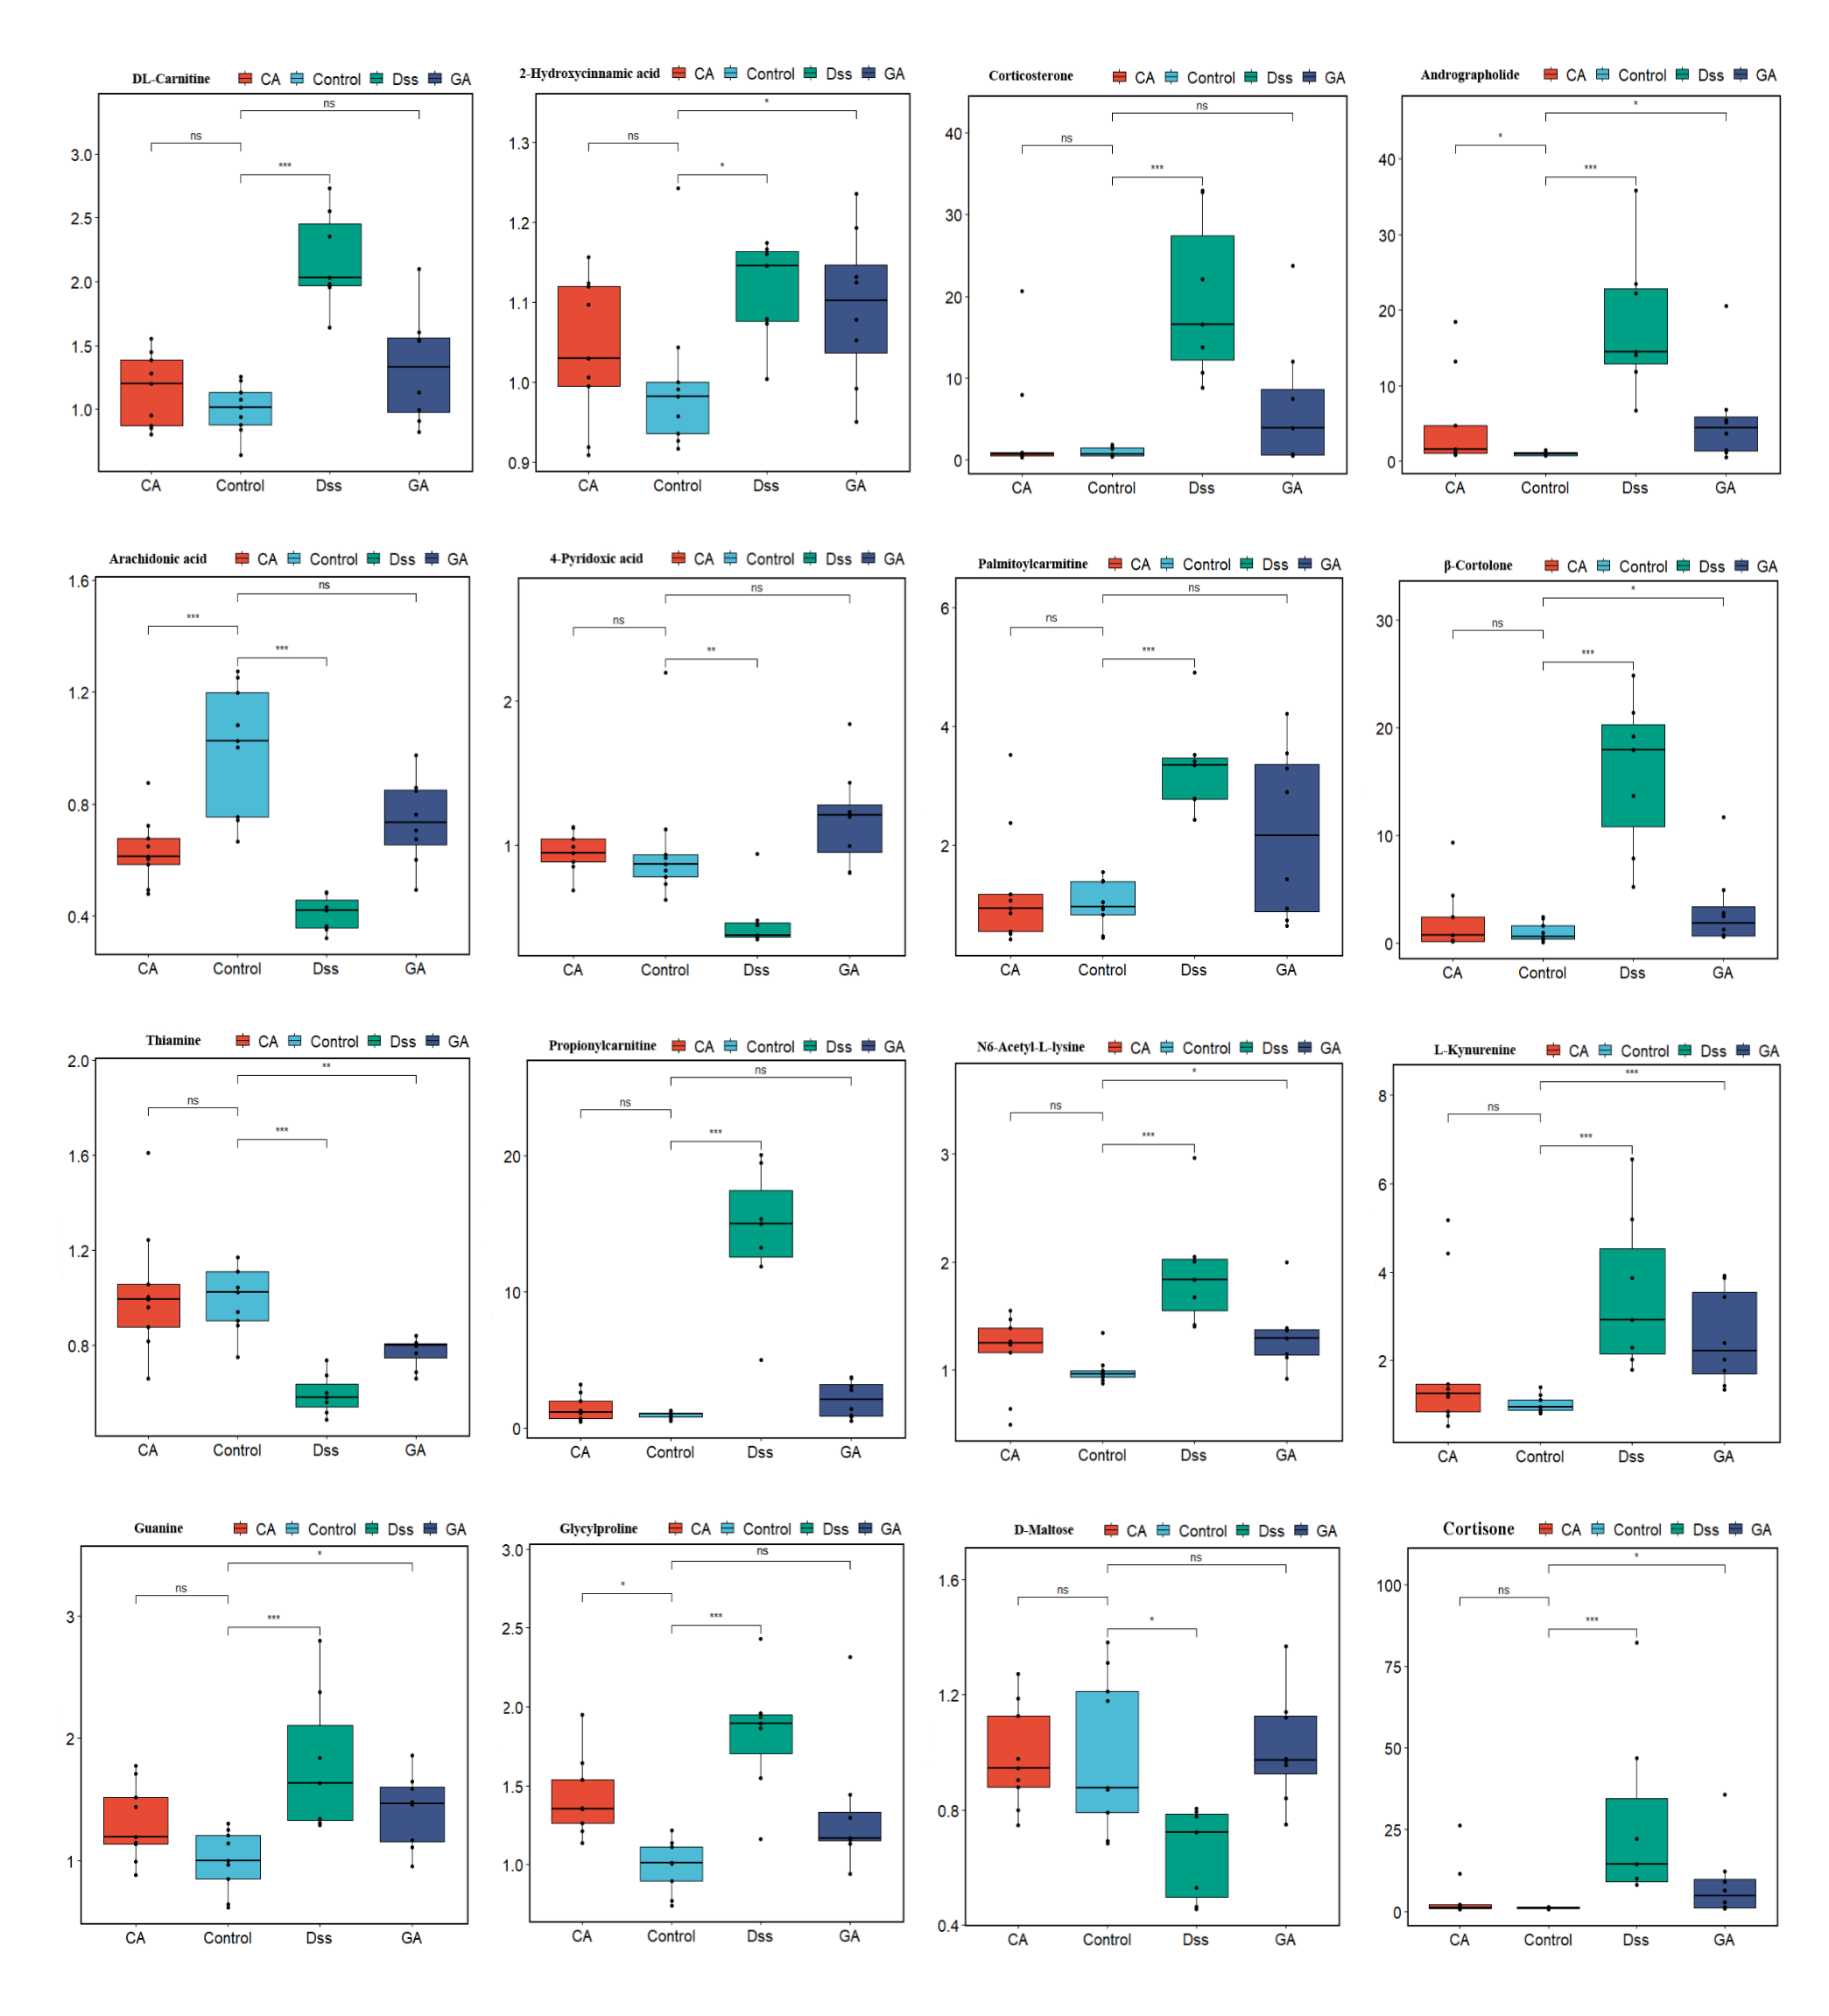
Figure S4

Table S1
NO. | Name | t_{R}[min] | MW | Formula | VIP | HMDB | KEGG | QC-mean±SD | QC-CV (%)
 | 11-Dehydrocorticosterone | 8.96 | 344.1975 | C₂₂H₄₃NO | 1.7226 | HMDB0004029 | C05490 | 2.59±0.19 | 7.14
 | 12-Aminododecanoicacid | 8.63 | 215.1878 | C₁₂H₂₅NO₂ | 0.2322 | NA* | NA | 1.81±0.14 | 7.68
 | 1-Linoleoylglycerol | 11.37 | 354.2754 | C₂₁H₃₄O₅ | 0.4088 | HMDB0011568 | NA | 4.77±0.80 | 16.83
 | 1-Methylhistidine | 1.21 | 169.0845 | C₇H₁₁N₃O₂ | 1.6566 | HMDB0000001 | C01152 | 4.38±0.75 | 17.21
 | 1-Tetradecylamine | 10.53 | 213.2449 | C₁₄H₃₁N | 1.6027 | NA | NA | 6.96±0.51 | 7.38
 | 2-Aminooctadec-4-yne-13-diol | 10.65 | 297.2657 | C₁₈H₃₅NO₂ | 0.4480 | NA | NA | 24.74±2.24 | 9.04
 | 2-Ethylamino-1-phenylbutane | 10.86 | 177.1511 | C₁₂H₁₉N | 0.5981 | NA | NA | 162.50±11.50 | 7.08
 | 2-Hydroxycinnamicacid | 1.80 | 164.0467 | C₉H₁₀O₄ | 1.0797 | HMDB0002641 | C01772 | 4241.86±411.88 | 9.71
 | 2-Hydroxypropylmethacrylate | 6.68 | 144.0783 | C₇H₁₂O₃ | 0.7010 | NA | NA | 1268.38±72.90 | 5.75
 | 34-Dihydroxyphenylpropionicacid | 1.40 | 182.0579 | C₉H₁₀O₄ | 0.6383 | HMDB0000423 | C10447 | 1594.57±141.57 | 8.88
 | 35-di-tert-Butyl-4-hydroxybenzaldehyde | 11.83 | 234.1610 | C₁₅H₂₂O₂ | 0.4697 | NA | NA | 36.78±2.84 | 7.73
 | 3'-Adenosinemonophosphate(3'-AMP) | 1.33 | 347.0618 | C₂₁H₃₀O₄ | 0.0356 | HMDB0003540 | C01367 | 57.97±4.88 | 8.43
 | 3-Hydroxypicolinicacid | 1.99 | 139.0265 | C₆H₅NO₃ | 0.3070 | HMDB0013188 | C18620 | 28.12±3.24 | 11.51
 | 3-Methylindole | 4.71 | 131.0731 | C₉H₉N | 1.9113 | HMDB0000466 | C08313 | 14.96±1.49 | 9.96
 | 4-Guanidinobutyricacid | 1.33 | 145.0846 | C₅H₁₁N₃O₂ | 0.2245 | HMDB0003464 | C01035 | 110.30±6.12 | 5.55
 | 4-Indolecarbaldehyde | 4.71 | 145.0523 | C₉H₇NO | 1.1363 | HMDB0029737 | C08493 | 36.26±3.59 | 9.89
 | 4-Phenyl-3-buten-2-one | 8.53 | 146.0726 | C₁₀H₁₀O | 0.1978 | HMDB0031617 | NA | 16.81±1.28 | 7.60
 | 4-Pyridoxicacid | 2.02 | 183.0526 | C₈H₉NO₄ | 1.1417 | HMDB0000017 | C00847 | 12.73±1.81 | 14.20
 | 5-Hydroxyindole | 6.48 | 133.0523 | C₈H₇NO | 1.2247 | HMDB0059805 | NA | 1.04±0.11 | 10.24
 | 5-Hydroxyindole-3-aceticacid | 3.26 | 191.0576 | C₁₀H₉NO₃ | 1.3794 | HMDB0000763 | C05635 | 181.54±31.82 | 17.53
 | 5'-Methylthioadenosine | 4.30 | 297.0885 | C₁₁H₁₅N₅O₃S | 2.0259 | HMDB0001173 | C00170 | 46.41±5.53 | 11.93
 | 6-Methylquinoline | 5.22 | 143.0730 | C₁₀H₉N | 0.7632 | HMDB0033115 | NA | 0.43±0.06 | 14.89
 | 7-Methylguanosine | 2.10 | 297.1063 | C₁₁H₁₅N₅O₅ | 1.0380 | HMDB0001107 | NA | 9.14±0.51 | 5.58
 | 9-OxoODE | 12.07 | 294.2183 | C₁₈H₃₀O₃ | 0.4602 | HMDB0004669 | C14766 | 5.38±0.49 | 9.07
 | Acetylcholine | 1.27 | 145.1098 | C₇H₁₅NO₂ | 0.9837 | HMDB0000895 | C01996 | 3.92±0.59 | 15.16
 | Acetyl-β-methylcholine | 1.33 | 159.1254 | C₈H₁₇NO₂ | 0.4188 | HMDB0015654 | C07471 | 107.01±6.34 | 5.92
 | Adenine | 1.30 | 135.0540 | C₅H₅N₅ | 0.6739 | HMDB0000034 | C00147 | 337.33±22.18 | 6.58
 | Adenosine | 1.70 | 267.0958 | C₁₀H₁₃N₅O₄ | 1.3600 | HMDB0000050 | C00212 | 33.34±5.33 | 16.00
 | Adenosine5'-monophosphate | 4.52 | 347.0619 | C₁₀H₁₄N₅O₇P | 0.5601 | HMDB0000045 | C00020 | 33.14±2.30 | 6.94
 | Adrenicacid | 15.06 | 332.2703 | C₂₂H₃₆O₂ | 0.9569 | HMDB0002226 | C16527 | 28.35±1.01 | 3.58
 | Andrographolide | 9.62 | 332.1976 | C₂₀H₃₀O₅ | 1.9006 | NA | NA | 4.56±0.68 | 14.91
 | Arachidonic acid | 14.09 | 304.2389 | C₂₀H₃₂O₂ | 1.4701 | HMDB0001043 | C00219 | 1.61±0.21 | 13.18
 | Asparagine | 1.21 | 132.0530 | C₄H₈N₂O₃ | 0.4017 | HMDB0000168 | C00152 | 427.89±33.41 | 7.81
 | Asymmetricdimethylarginine | 1.22 | 202.1423 | C₈H₁₈N₄O₂ | 1.0467 | HMDB0001539 | C03626 | 275.63±20.16 | 7.31
 | Benzophenone | 10.90 | 182.0727 | C₁₃H₁₀O | 0.4691 | HMDB0032049 | C06354 | 204.44±11.65 | 5.70
 | Benzotriazole | 5.80 | 119.0482 | C₆H₅N₃ | 0.0085 | NA | NA | 14.73±1.16 | 7.88
 | Betaine | 1.25 | 117.0787 | C₅H₁₁NO₂ | 1.4749 | HMDB0000043 | C00719 | 15.79±2.20 | 13.96
 | Caprolactam | 4.87 | 113.0840 | C₆H₁₁NO | 0.3576 | HMDB0062769 | C06593 | 4401.22±159.60 | 3.63
 | Choline | 1.22 | 103.0997 | C₅H₁₃NO | 0.8600 | HMDB0000097 | C00114 | 31.89±5.06 | 15.86
 | Cis-stilbeneoxide | 11.32 | 196.0883 | C₁₄H₁₂O | 0.6494 | HMDB0059631 | C16014 | 1586.61±63.52 | 4.00
 | Corticosterone | 8.08 | 346.2132 | C₂₁H₂₈O₄ | 2.2513 | HMDB0001547 | C02140 | 2.64±0.30 | 11.37
 | Cortisol | 8.62 | 362.2080 | C₂₁H₃₀O₅ | 2.6231 | HMDB0000063 | C00735 | 2.52±0.20 | 7.74
 | Cortisone | 8.38 | 360.1924 | C₂₁H₂₈O₅ | 1.9028 | HMDB0002802 | C00762 | 16.70±1.18 | 7.04
 | Creatine | 1.26 | 131.0691 | C₄H₉N₃O₂ | 0.5857 | HMDB0000064 | C00300 | 1.68±0.13 | 7.49
 | Cyclohexylamine | 2.98 | 82.0784 | C₆H₁₃N | 0.5622 | HMDB0031404 | C00571 | 1000.54±34.14 | 3.41
 | Cytidine | 1.28 | 243.0846 | C₉H₁₃N₃O₅ | 0.8924 | HMDB0000089 | C00475 | 161.89±26.94 | 16.64
 | Cytosine | 1.28 | 111.0432 | C₄H₅N₃O | 0.7514 | HMDB0000630 | C00380 | 62.68±5.05 | 8.05
 | Daidzein | 7.78 | 254.0569 | C₁₅H₁₀O₄ | 0.4528 | HMDB0003312 | C10208 | 103.72±7.03 | 6.78
 | L-Carnitine | 1.24 | 161.1046 | C₇H₁₅NO₃ | 1.3212 | HMDB0000062 | C00318 | 2.72±0.29 | 10.73
 | L-Stachydrine | 1.30 | 143.0941 | C₇H₁₃NO₂ | 1.5429 | NA | NA | 2043.05±71.07 | 3.48
 | L-Tryptophan | 4.71 | 204.0891 | C₁₁H₁₂N₂O₂ | 0.2046 | HMDB0013609 | C00525 | 54.36±8.48 | 15.60
 | D-Maltose | 1.21 | 364.0968 | C₁₂H₂₂O₁₁ | 1.1307 | HMDB0000163 | C00208 | 1949.46±282.33 | 14.48
 | Docosapentaenoic acid | 14.22 | 330.2547 | C₂₂H₃₄O₂ | 1.2645 | HMDB0006528 | C16513 | 137.42±11.53 | 8.39
 | D-Raffinose | 1.21 | 526.1491 | C₁₈H₃₂O₁₆ | 0.8539 | HMDB0003213 | C00492 | 25.23±1.20 | 4.74
 | Eicosapentaenoic acid | 12.05 | 302.2234 | C₂₀H₃₂O₃ | 1.2404 | HMDB0001999 | C06428 | 104.36±7.02 | 6.73
 | Erucamide | 16.64 | 337.3329 | C₂₁H₃₈O₄ | 1.0240 | NA | NA | 148.36±18.81 | 12.68
 | Ethyllevulinate | 4.55 | 144.0782 | C₇H₁₂O₃ | 0.6167 | NA | NA | 4.58±0.64 | 13.86
 | Flurandrenolide | 5.61 | 436.2269 | C₂₄H₃₃FO₆ | 0.0177 | HMDB0014984 | NA | 8.72±0.65 | 7.45
 | Folinicacid | 4.14 | 473.1644 | C₂₀H₂₃N₇O₇ | 0.9469 | HMDB0001562 | C03479 | 22.63±2.95 | 13.04
 | Glucose1-phosphate | 1.26 | 260.0287 | C₆H₁₃O₉P | 1.2803 | HMDB0001586 | C00103 | 23.96±2.19 | 9.15
 | Glutamylglutamic acid | 1.31 | 276.0948 | C₁₀H₁₆N₂O₇ | 0.0210 | HMDB0028818 | C01425 | 34.64±6.17 | 17.81
 | Glycylleucine | 4.28 | 188.1155 | C₈H₁₆N₂O₃ | 0.4773 | HMDB0000759 | C02155 | 48.39±4.41 | 9.11
 | Glycylproline | 1.70 | 172.0843 | C₇H₁₂N₂O₃ | 1.1102 | HMDB0000721 | NA | 8.30±1.25 | 15.12
 | Guanine | 1.34 | 151.0488 | C₅H₅N₅O | 1.0463 | HMDB0000132 | C00242 | 14.53±0.67 | 4.58
 | Hypotaurine | 1.23 | 109.0197 | C₂H₇NO₂S | 2.1608 | HMDB0000965 | C00519 | 21.32±1.86 | 8.72
 | Hypoxanthine | 1.34 | 136.0380 | C₅H₄N₄O | 0.0208 | HMDB0000157 | C00262 | 124.01±6.82 | 5.50
 | Indan-1-ol | 10.84 | 134.0727 | C₉H₁₀O | 0.0740 | HMDB0059601 | C01710 | 2870.51±257.20 | 8.96
 | Indole-3-acetate | 4.71 | 117.0574 | C₈H₇N | 0.3581 | HMDB0000738 | C00463 | 41.12±5.47 | 13.30
 | Indoleacrylicacid | 4.71 | 187.0626 | C₁₁H₉NO₂ | 0.2990 | HMDB0000734 | NA | 39.70±3.69 | 9.29
 | Inosine | 1.34 | 268.0797 | C₁₀H₁₂N₄O₅ | 0.7218 | HMDB0000195 | C00294 | 1944.14±282.32 | 14.52
 | Isoquinoline | 4.71 | 129.0575 | C₉H₇N | 0.2104 | HMDB0034244 | C06323 | 96.95±5.15 | 5.31
 | Kynurenic acid | 4.86 | 189.0419 | C₁₀H₇NO₃ | 0.9245 | HMDB0000715 | C01717 | 16.04±2.37 | 14.77
 | LL-Cyclo(leucylprolyl) | 4.29 | 210.1362 | C₁₁H₁₈N₂O₂ | 0.6868 | HMDB0034276 | NA | 1.77±0.24 | 13.29
 | L-Asparticacid | 1.23 | 133.0371 | C₄H₇NO₄ | 0.4597 | HMDB0000191 | C00049 | 1.47±0.18 | 12.52
 | Laurolactam | 11.15 | 197.1773 | C₁₂H₂₃NO | 1.1167 | NA | NA | 177.53±10.87 | 6.12
 | L-Cystathionine | 1.15 | 222.0668 | C₇H₁₄N₂O₄S | 0.4472 | HMDB0000099 | C02291 | 3.28±0.21 | 6.47
 | L-Ergothioneine | 1.29 | 229.0877 | C₉H₁₅N₃O₂S | 1.1688 | HMDB0003045 | C05570 | 1.80±0.24 | 13.40
 | Leucine | 2.09 | 131.0942 | C₆H₁₃NO₂ | 0.5592 | HMDB0000687 | C00123 | 347.75±19.30 | 5.55
 | Leucylproline | 4.36 | 228.1467 | C₁₁H₂₀N₂O₃ | 0.8483 | HMDB0011175 | NA | 5805.72±751.94 | 12.95
 | L-Glutamic acid | 1.23 | 147.0526 | C₅H₉NO₄ | 0.6331 | HMDB0000148 | C00025 | 23.26±3.86 | 16.59
 | L-Histidine | 1.13 | 155.0689 | C₆H₉N₃O₂ | 0.0351 | HMDB0000177 | C00135 | 3670.45±100.50 | 2.74
 | L-Kynurenine | 3.25 | 208.0841 | C₁₀H₁₂N₂O₃ | 1.3739 | HMDB0000684 | C00328 | 1021.09±102.15 | 10.00
 | L-Lysine | 1.13 | 146.1050 | C₆H₁₄N₂O₂ | 0.6405 | HMDB0000182 | C00047 | 158.01±24.15 | 15.29
 | L-Phenylalanine | 3.33 | 165.0784 | C₉H₁₁NO₂ | 0.4324 | HMDB0000159 | C00079 | 3015.29±181.93 | 6.03
 | L-Pyroglutamic acid | 1.22 | 129.0422 | C₅H₇NO₃ | 0.6353 | HMDB0000267 | C01879 | 10921.79±1342.30 | 12.29
 | L-Serine | 1.22 | 105.0420 | C₃H₇NO₃ | 0.3078 | HMDB0000187 | C00065 | 3674.33±155.43 | 4.23
 | L-Threonine | 1.23 | 87.0318 | C₄H₉NO₃ | 0.0790 | HMDB0000167 | C00188 | 2272.58±117.22 | 5.16
 | Melatonin | 7.28 | 232.1203 | C₁₃H₁₆N₂O₂ | 1.0677 | HMDB0001389 | C01598 | 737.16±37.35 | 5.07
 | Methenolone | 11.94 | 302.2233 | C₂₀H₃₂O₃ | 0.9060 | HMDB0041928 | C14778 | 1.52±0.18 | 12.10
 | Methionine | 1.68 | 149.0505 | C₅H₁₁NO₂S | 0.4320 | HMDB0000696 | C00073 | 11.93±1.91 | 16.03
 | Methyl hexadecanoic acid | 10.57 | 270.2558 | C₁₇H₃₄O₂ | 1.8099 | HMDB0061859 | C16995 | 1991.32±171.39 | 8.61
 | Methylimidazoleacetic acid | 1.33 | 140.0583 | C₆H₈N₂O₂ | 0.5823 | HMDB0002820 | C05828 | 78.76±2.87 | 3.64
 | N6N6N6-Trimethyl-L-lysine | 1.14 | 188.1519 | C₉H₂₀N₂O₂ | 0.8174 | HMDB0001325 | C03793 | 1919.60±224.44 | 11.69
 | N6-Acetyl-L-lysine | 1.28 | 188.1154 | C₈H₁₆N₂O₃ | 1.1674 | HMDB0000206 | C02727 | 40.86±4.37 | 10.69
 | Nicotinamide | 1.42 | 122.0477 | C₆H₆N₂O | 0.1353 | HMDB0001406 | C00153 | 36.28±2.61 | 7.19
 | N-Methylnicotinamide | 1.22 | 136.0632 | C₇H₈N₂O | 1.5334 | HMDB0003152 | NA | 2036.24±217.92 | 10.70
 | N-Oleoylethanolamine | 14.84 | 325.2968 | C₂₀H₃₅NO₂ | 1.3606 | HMDB0002088 | NA | 19.23±1.11 | 5.79
 | Oleamide | 14.47 | 281.2707 | C₁₈H₃₅NO | 0.7535 | HMDB0002117 | C19670 | 27.03±2.83 | 10.47
 | Ornithine | 1.13 | 132.0896 | C₅H₁₂N₂O₂ | 0.6705 | HMDB0000214 | C00077 | 369.27±40.59 | 10.99
 | Glutathione | 1.33 | 307.0838 | C₁₀H₁₇N₃O₆S | 0.9493 | HMDB0000125 | C00051 | 1248.28±83.22 | 6.67
 | Palmitic amide | 14.33 | 255.2550 | C₁₆H₃₃NO | 0.9479 | HMDB0012273 | NA | 2954.93±184.41 | 6.24
 | Palmitoleic acid | 11.64 | 254.2235 | C₁₆H₃₀O₂ | 0.9248 | HMDB0003229 | C08362 | 130.21±7.50 | 5.76
 | Palmitoyl ethanol amide | 13.61 | 299.2812 | C₁₈H₃₇NO₂ | 0.6372 | HMDB0002100 | C16512 | 20.57±1.29 | 6.29
 | Palmitoyl carnitine | 11.76 | 399.3334 | C₂₃H₄₅NO₄ | 1.4765 | HMDB0000222 | C02990 | 7.69±0.56 | 7.26
 | Phenylacetyl glycine | 6.02 | 193.0733 | C₁₀H₁₁NO₃ | 0.0997 | HMDB0000821 | C05598 | 7.25±0.59 | 8.19
 | Pipecolic acid | 1.33 | 129.0787 | C₆H₁₁NO₂ | 1.0311 | HMDB0000070 | C00408 | 7.19±0.70 | 9.72
 | Prolin amide | 1.13 | 114.0792 | C₅H₁₀N₂O | 0.1869 | NA | NA | 84.73±14.38 | 16.97
 | Proline | 1.27 | 115.0631 | C₅H₉NO₂ | 0.8502 | HMDB0000162 | C00148 | 113.75±9.33 | 8.20
 | Propionylcarnitine | 2.31 | 217.1307 | C₁₀H₁₉NO₄ | 2.3799 | HMDB0000824 | C03017 | 3785.77±169.52 | 4.48
 | Punicic acid | 11.74 | 278.2234 | C₁₈H₃₀O₂ | 0.0476 | HMDB0030963 | C08364 | 142.47±23.86 | 16.75
 | Retinal | 12.05 | 284.2129 | C₂₀H₂₈O | 1.2691 | HMDB0001358 | C00376 | 134.42±11.76 | 8.75
 | Sedanolide | 13.49 | 176.1194 | C₁₂H₁₈O₂ | 0.6760 | HMDB0034450 | C17002 | 5.94±0.65 | 11.01
 | Spermidine | 1.06 | 145.1574 | C₇H₁₉N₃ | 0.2618 | HMDB0001257 | C00315 | 6.03±1.08 | 17.83
 | Sphingosine | 11.07 | 299.2813 | C₁₈H₃₇NO₂ | 0.4242 | HMDB0000252 | NA | 39.16±4.54 | 11.59
 | Stearamide | 14.98 | 283.2863 | C₁₈H₃₇NO | 0.8138 | HMDB0034146 | C13846 | 401.29±54.45 | 13.57
 | Taurine | 1.24 | 125.0144 | C₂H₇NO₃S | 0.9290 | HMDB0000251 | C00245 | 24.91±4.07 | 16.32
 | Taurocholicacid | 7.39 | 515.2900 | C₂₆H₄₅NO₇S | 0.8195 | HMDB0000036 | C05122 | 529.89±39.45 | 7.45
 | Tetracosahexaenoic acid | 10.07 | 356.2703 | C₂₄H₃₆O₂ | 0.1381 | HMDB0002007 | NA | 15.21±1.65 | 10.83
 | Tetraglyme | 5.24 | 222.1460 | C₁₀H₂₂O₅ | 0.6838 | NA | NA | 6.26±0.62 | 9.92
 | Thiamine | 1.18 | 264.1037 | C₁₂H₁₆N₄OS | 1.1181 | HMDB0000235 | C00378 | 3.50±0.57 | 16.42
 | Thymine | 2.68 | 126.0426 | C₅H₆N₂O₂ | 0.8081 | HMDB0000262 | C00178 | 88.40±8.48 | 9.59
 | Tributylphosphate | 11.78 | 266.1636 | C₁₂H₂₇O₄P | 0.3925 | NA | NA | 118.99±15.68 | 13.18
 | Tributylamine | 8.00 | 185.2137 | C₁₂H₂₇N | 0.6013 | NA | NA | 20.88±3.63 | 17.41
 | Tridemorph | 16.26 | 297.3020 | C₁₉H₃₉NO | 0.6027 | HMDB0031810 | C11285 | 5.72±0.24 | 4.18
 | Trigonelline | 1.27 | 137.0472 | C₇H₇NO₂ | 0.5009 | HMDB0000875 | C01004 | 65.57±6.31 | 9.62
 | Umbelliferone | 9.11 | 162.0311 | C₉H₆O₃ | 0.5439 | HMDB0029865 | C09315 | 86.24±14.44 | 16.74
 | Uracil | 1.35 | 112.0272 | C₄H₄N₂O₂ | 1.0356 | HMDB0000300 | C00106 | 426.58±39.78 | 9.32
 | Uricacid | 1.68 | 168.0277 | C₅H₄N₄O₃ | 0.3388 | HMDB0000289 | C00366 | 1.40±0.16 | 11.15
 | Valine | 1.70 | 117.0788 | C₅H₁₁NO₂ | 0.1652 | HMDB0000883 | C00183 | 1264.75±119.28 | 9.43
 | Vanillin | 6.37 | 152.0469 | C₈H₈O₃ | 0.6170 | HMDB0012308 | C00755 | 4.58±0.42 | 9.18
 | α-Aminocaprylicacid | 5.96 | 159.1254 | C₈H₁₇NO₂ | 1.2014 | HMDB0000991 | NA | 3.47±0.36 | 10.46
 | α-Linolenoylethanolamide | 13.43 | 321.2654 | C₂₀H₃₉NO₂ | 0.4668 | HMDB0013624 | C13828 | 16.41±1.61 | 9.79
 | β-Cortolone | 8.32 | 348.2289 | C₁₀H₁₄N₅O₇P | 2.2887 | HMDB0013221 | C05481 | 7.26±0.72 | 9.86
*NA means not available

Table S2
NO. | Name | t_{R}(min) | HMDB | KEGG | VIP>1 | Relative intensity
 |  |  |  |  |  | Control | DSS | CA | GA
 | Propionyl carnitine | 2.31 | HMDB0000824 | C03017 | ∆ª | 384.21±98.64 | 5700.72±2028.84^{c} | 588.66±375.78 | 847.76±530.07
 | 5'-Methylthioadenosine | 4.30 | HMDB0001173 | C00170 | ∆ | 1098.98±412.73 | 177.72±98.85^{c} | 332.70±173.15e | 144.91±32.16^{g}
 | Arachidonic acid | 14.09 | HMDB0001043 | C00219 | ∆ | 5997.26±1389.78 | 2527.74±396.91^{c} | 3919.27±744.50 e | 4579.15±951.61
 | Asymmetric dimethylarginine | 1.22 | HMDB0001539 | C03626 | ∆ | 1460.57±176.09 | 3332.94±550.11^{c} | 2628.13±663.53e | 2836.92±632.09^{g}
 | 2-Hydroxycinnamic acid | 1.80 | HMDB0002641 | C01772 | ∆ | 41814.40±4160.80 | 46614.17±2664.52^{b} | 43477.82±3774.49 | 45783.97±4025.79^{f}
 | Eicosapentaenoic acid | 12.05 | HMDB0001999 | C06428 | ∆ | 598.51±157.37 | 1678.50±496.18^{c} | 1621.33±624.38e | 1823.51±580.45^{g}
 | Hypotaurine | 1.23 | HMDB0000965 | C00519 | ∆ | 284.55±70.53 | 4235.41±2659.97^{c} | 358.70±289.65 | 606.52±428.58 ^{f}
 | 7-Methylguanosine | 2.10 | HMDB0001107 | NA | ∆ | 38.09±6.43 | 30.11±10.26^{b} | 69.08±28.06 | 90.16±21.60^{f}
 | L-Glutamic acid | 1.23 | HMDB0000148 | C00025 | - | 43708.36±3309.61 | 32873.93±4521.91^{c} | 49026.16±6615.43 | 45206.38±8915.42
 | Retinal | 12.05 | HMDB0001358 | C00376 | ∆ | 22.37±7.07 | 64.89±18.81^{c} | 64.41±27.57^{d} | 71.68±23.30^{f}
 | D-Maltose | 1.21 | HMDB0000163 | C00208 | ∆ | 1779.42±483.21 | 1155.87±283.50^{b} | 1747.31±317.29 | 1807.18±343.14
 | 3-Hydroxypicolinic acid | 1.99 | HMDB0013188 | C18620 | - | 491.67±158.22 | 92.85±40.66^{c} | 302.80±154.85^{d} | 210.48±85.69^{f}
 | L-Aspartic acid | 1.23 | HMDB0000191 | C00049 | - | 1554.21±229.08 | 1567.27±281.41^{b} | 2305.17±653.31^{d} | 2752.15±634.34^{g}
 | 4-Pyridoxic acid | 2.02 | HMDB0000017 | C00847 | ∆ | 144.45±66.08 | 65.88±29.11^{b} | 131.24±19.31 | 164.84±46.90
 | L-Pyroglutamic acid | 1.22 | HMDB0000267 | C01879 | - | 54674.52±10108.24 | 40393.45±5735.67^{c} | 39412.07±7405.37e | 32386.24±5305.82^{g}
 | 2-Ethylamino-1-phenylcutane | 10.86 | NA* | NA | - | 2045.60±449.19 | 1318.40±406.96^{c} | 1377.93±208.93e | 1087.82±196.00^{g}
 | Cortisol | 8.62 | HMDB0000063 | C00735 | ∆ | 11.69±9.99 | 506.20±352.53^{c} | 21.59±20.54 | 73.07±52.63 ^{g}
 | Guanine | 1.34 | HMDB0000132 | C00242 | ∆ | 187.17±47.36 | 336.74±109.82^{c} | 245.23±58.58 | 263.57±57.07^{f}
 | Glucose 1-phosphate | 1.26 | HMDB0001586 | C00103 | ∆ | 578.68±137.07 | 235.28±78.19^{c} | 400.70±75.89e | 322.36±76.24^{g}
 | Uracil | 1.35 | HMDB0000300 | C00106 | ∆ | 4359.67±764.58 | 2963.04±608.96^{b} | 5243.61±1162.11 | 3965.74±1520.60
 | L-Carnitine | 1.24 | HMDB0000062 | C00318 | ∆ | 17807.48±3512.00 | 38793.25±6811.27^{c} | 20469.79±5089.24 | 23672.54±7816.16
 | Docosapentaenoic acid | 14.22 | HMDB0006528 | C16513 | ∆ | 444.91±91.67 | 166.56±53.25^{c} | 195.88±60.57e | 184.92±67.95^{g}
 | Adenosine | 1.70 | HMDB0000050 | C00212 | ∆ | 730.08±120.65 | 250.33±64.90^{c} | 357.95±117.34e | 287.89±137.51^{g}
 | β-Cortolone | 8.32 | HMDB0013221 | C05481 | ∆ | 18.50±12.94 | 234.38±106.55^{c} | 5.97±4.67 | 28.75±24.15 ^{f}
 | Corticosterone | 8.08 | HMDB0001547 | C02140 | ∆ | 3.72±2.15 | 73.06±37.02^{c} | 2.27±0.84 | 37.94±30.86
 | Methenolone | 11.94 | HMDB0041928 | C14778 | - | 64.65±15.56 | 115.30±21.72^{c} | 136.57±50.60^{d} | 169.54±45.97^{g}
 | Andrographolide | 9.62 | NA | NA | ∆ | 2.31±0.62 | 42.36±22.28^{c} | 4.05±3.04 | 8.07±5.67
 | 6-Methylquinoline | 5.22 | HMDB0033115 | NA | - | 5.77±1.38 | 22.75±19.17^{b} | 120.10±21.40^{d} | 130.42±30.00^{f}
 | Glycylproline | 1.70 | HMDB0000721 | NA | ∆ | 116.59±19.36 | 213.04±45.74^{c} | 164.62±29.84^{d} | 154.76±49.39
 | Thiamine | 1.18 | HMDB0000235 | C00378 | ∆ | 1213.24±172.57 | 721.46±104.90^{c} | 1244.25±330.44 | 936.37±77.03 ^{g}
 | L-Lysine | 1.13 | HMDB0000182 | C00047 | - | 29151.52±2521.68 | 33767.78±3753.10^{c} | 33830.65±2981.41e | 33761.14±2650.19^{f}
 | Methyl palmitate | 10.57 | HMDB0061859 | C16995 | ∆ | 1232.15±479.27 | 991.14±697.34^{b} | 1958.65±485.88e | 1765.57±524.24
 | 1-Linoleoyl-glycerol | 11.37 | HMDB0011568 | NA | - | 97.03±38.75 | 25.16±7.68^{c} | 45.01±26.57 | 40.44±14.31^{g}
 | Glutathione | 1.33 | HMDB0000125 | C00051 | - | 39617.25±6036.10 | 22513.56±4980.63^{c} | 34831.89±6374.22 | 34240.51±8982.61
 | N6-Acetyl-L-lysine | 1.28 | HMDB0000206 | C02727 | ∆ | 265.83±37.06 | 507.29±141.26^{c} | 309.20±95.39 | 350.36±83.69 ^{f}
 | 1-Methylhistidine | 1.21 | HMDB0000001 | C01152 | ∆ | 24.66±5.94 | 161.44±147.60^{c} | 57.68±37.67 | 46.83±24.04^{g}
 | Proline | 1.27 | HMDB0000162 | C00148 | - | 33937.34±3695.64 | 44781.44±2913.57^{c} | 44552.87±6466.65^{d} | 46503.85±10299.32^{g}
 | N-Methylnicotinamide | 1.22 | HMDB0003152 | NA | ∆ | 72.84±27.93 | 294.83±175.09^{c} | 235.06±174.69^{d} | 173.92±75.76^{f}
 | Laurolactam | 11.15 | NA | NA | ∆ | 37.00±15.58 | 25.87±4.44^{b} | 26.54±5.97 | 23.79±7.61^{f}
 | L-Tryptophan | 4.71 | HMDB0013609 | C00525 | - | 19095.86±3431.75 | 19538.41±1573.71^{b} | 21380.54±1237.99 | 23131.40±1787.06^{f}
 | 5-Hydroxyindole-3-acetic acid | 3.26 | HMDB0000763 | C05635 | ∆ | 803.38±155.86 | 2930.29±1433.09^{c} | 1543.38±1302.91 | 2375.03±1305.74^{f}
 | Cytosine | 1.28 | HMDB0000630 | C00380 | - | 1262.22±207.41 | 1102.20±154.74^{b} | 1093.37±293.15 | 1169.39±263.20
 | L-Serine | 1.22 | HMDB0000187 | C00065 | - | 33888.95±6847.63 | 26077.73±3462.08^{c} | 23371.27±5026.17e | 19459.48±3664.87^{g}
 | Cytidine | 1.28 | HMDB0000089 | C00475 | - | 906.25±203.81 | 632.67±155.92^{b} | 714.93±241.36 | 717.68±183.08
 | L-Kynurenine | 3.25 | HMDB0000684 | C00328 | ∆ | 654.22±129.20 | 2302.36±1173.26^{c} | 1233.12±1104.86 | 1653.55±699.91^{g}
 | Benzotriazole | 5.80 | NA | NA | - | 115.32±30.24 | 117.72±40.84^{b} | 60.61±32.43e | 106.96±27.18
 | Adenosine 5'-monophosphate | 4.52 | HMDB0000045 | C00020 | - | 454.96±129.09 | 307.76±56.43^{b} | 503.40±81.84 | 440.64±38.22
 | 2-Hydroxypropyl methacrylate | 6.68 | NA | NA | - | 13422.12±3602.44 | 10060.25±2172.58^{c} | 11174.65±1769.03 | 8035.20±2318.02^{g}
 | Palmitoyl carnitine | 11.76 | HMDB0000222 | C02990 | ∆ | 39.64±15.63 | 131.29±32.20^{c} | 39.09±24.66 | 87.65±56.63
 | Palmitoleic acid | 11.64 | HMDB0003229 | C08362 | - | 170.86±37.15 | 254.46±62.47^{c} | 218.10±32.63e | 195.55±44.31
 | Indole-3-acetate | 4.71 | HMDB0000734 | NA | - | 19054.46±3424.91 | 19968.82±1833.57^{b} | 20716.54±2195.55 e | 23069.60±1769.34^{f}
 | Cortisone | 8.38 | HMDB0002802 | C00762 | ∆ | 1.81±0.46 | 33.18±27.09^{b} | 2.02±0.92 | 10.02±8.24 ^{f}
*NA means not available. ª ∆ means VIP>1 in OPLS-DA. ^{b}DSS group compared with control group, p<0.05. ^{c}DSS group compared with control group, p<0.01. ^{d}CA group compared with control group, p<0.05. ^{e}CA group compared with control group, p<0.01. ^{f}GA group compared with control group, p<0.05. ^{g}GA group compared with control group, p<0.01.

